**Stefanie Voss**

**LEADER on my SHIP: Success Strategies of a Circumnavigator**

What is the secret of success? Passionate sailing enthusiast Stefanie Voss has a simple, pragmatic answer to this exciting question: “Successful people are able to mindfully lead themselves. And that is also exactly what makes a good sailor.“ If one wants to cross the open seas, they must have a clear focus on their goals, confidence in their own capabilities, and a willingness to deal creatively with adverse circumstances.

Global keynote speaker Stefanie Voss is convinced: No matter if it’s a gale force wind or dense fog, instead of complaining about bad weather a good sailor makes the best of the existing realities, in the same way that successful people must deal constructively with difficult colleagues and complex issues at the workplace. Whether in an office or a workshop, a doctor or a teacher, successful people do not lose sight of their objectives. Even in stormy times they remain focused and calm.

Circumnavigator and successful business executive Stefanie Voss pulls from her own practical experiences. She draws parallels between stormy seas and times of change in a business organization or a market environment.

“Anyone can learn to set a clear and straight course when dealing with others.” Communications expert Stefanie Voss knows this well from her professional experience in a German DAX-rated corporation. “Those who consistently work on their individual self-leadership and personal achievements will also make valuable contributions to successful teams.”

In her engaging presentations, Voss offers the principles she has learned both at sea and on land: being proactive, making clear decisions, and having a straightforward communication style make people successful. Her audiences are encouraged and inspired to take the helm in their own lives, both privately and professionally.

**Contents of the presentation:**

* Self-leadership, clearly defined
* Knowing your destination and planning your route accordingly
* Those that speak clearly, speak through the storm
* The (un)importance of circumstances
* I am the captain of my life’s ship

**Stefanie Voss**

Keynote Speaker – Leadership & Team Coach – Circumnavigator – Author

***\*\* business mind meets pirate soul \*\****

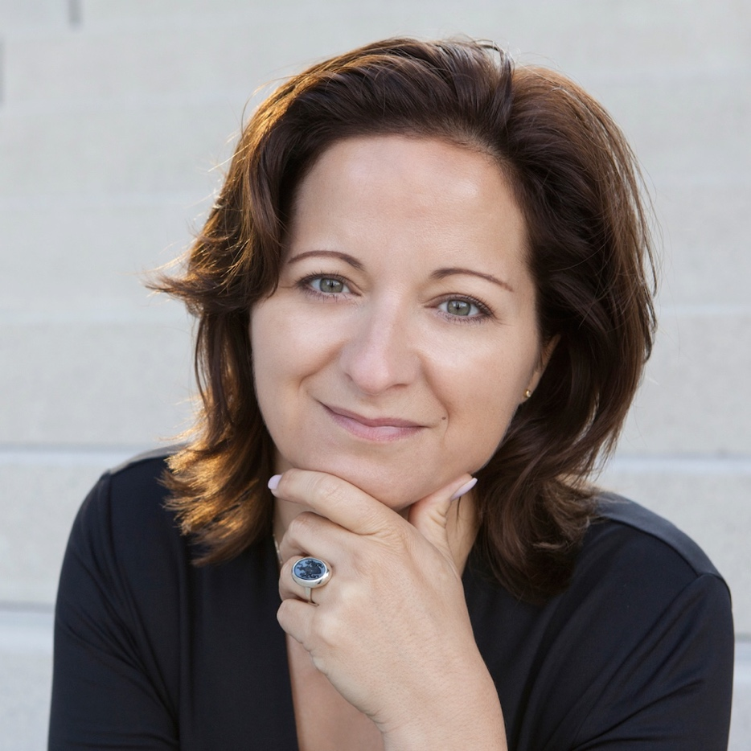

**Short Profile:**

Stefanie Voss was recently introduced as "Ms. Blackbeard - the business woman with the pirate soul", a nickname that suits her well. She is an open-minded and audacious personality who consistently makes unusual decisions far from "what one should do”. She went to the USA as an exchange student at the age of 16, moved to Argentina for her employer when she was 23 and became crew on a sailing yacht at age 25 to circumnavigate the globe. At the age of 31, she became department head in a DAX company with extensive budget and personnel responsibilities. After 15 years in her very successful corporate career, she changed course in 2009 and founded her own company. As a speaker and coach, she covers topics like leadership, VUCA, diversity, pirate strategy and agility. She works internationally for large corporations, SMEs, freelancers, and the social and public sector. This includes companies like Bosch, Fresenius, GEA, Merck, Paypal, Roche, Thyssenkrupp and many others. In 2023, she published her first book “THE PIRATE STRATEGY – Life without ifs and buts” in German at CAMPUS Publishers.

**Website:** [www.stefanie-voss.de](http://www.stefanie-voss.de)

**Book (in German only):** [www.piratenstrategie.de](http://www.piratenstrategie.de)

**Social Media Profiles:**

LinkedIn: <http://www.linkedin.com/in/stefanievoss>

YouTube: <https://www.youtube.com/c/StefanieVoss>

**Keynote Languages:**

German (mother tongue)

English (fluent without accent)

**Contact for Keynote Bookings:**

[office@stefanie-voss.de](mailto:Stefanie.voss@cutwater.de)

+49 160 96346969